**INTRODUCTION:**

1.1 OVERVIEW:

As the backbone of Indian economy, the agriculture industry contributes to around 16.5% of India’s GDP. As of 2022, the Indian agriculture market value stood at USD 435.9 billion and is expected t reach USD 580.82 billion by 2028, growing at a CAGR of around 4.9% between 2023 and 2028.

1.2 PURPOSE :

Crop production is one of the fundamental branches of agriculture. Crop production is the basis for providing the livestock industry with feed, and the population with food. Also, crop products are used in many industries as raw materials of plant origin, such as food, textile, pharmaceutical, fuel and others.

Agriculture is the foundation of Indian economy. The population of India mostly depends on agriculture for their livelihood and agriculture contributes to 40 percent of the total GDP of the country.

**PROBLEM DEFINITION AND DESIGN THINKING:**

2.1 EMPATHY MAP

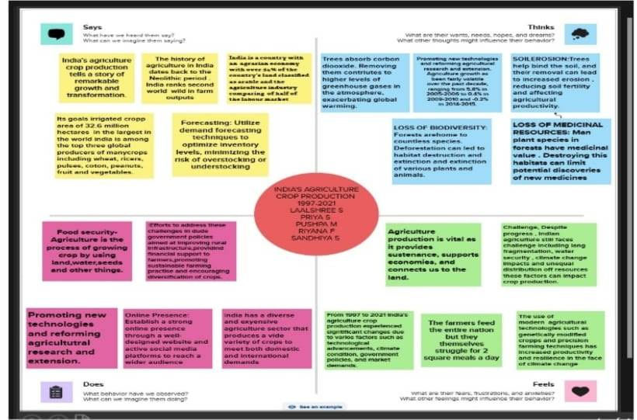

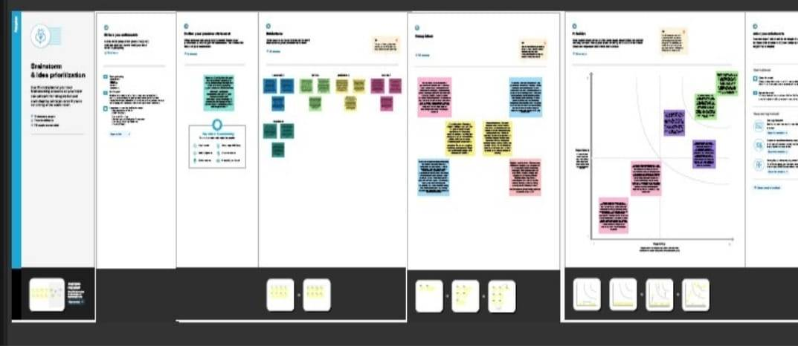2.2 IDEATION AND BRAINSTORMING MAP:

**RESULT:**

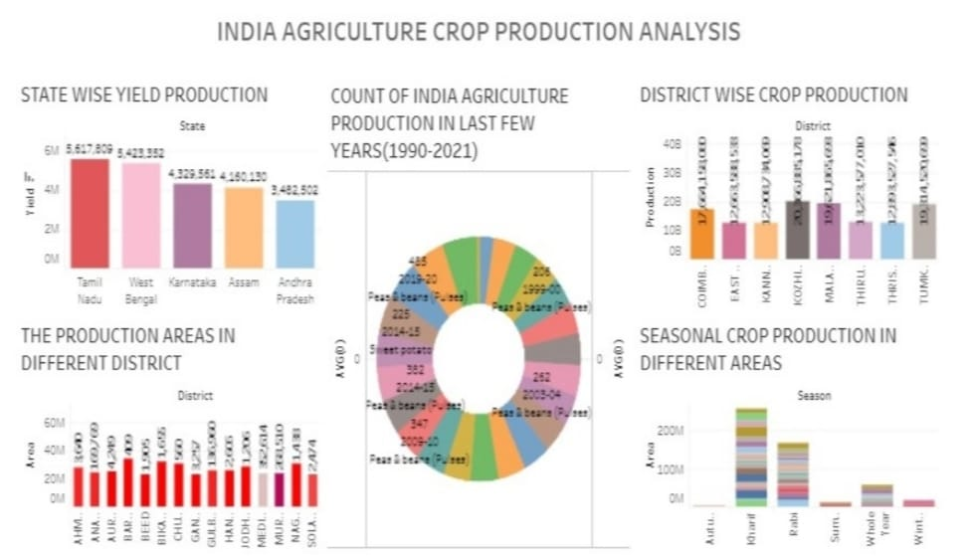**DASHBOARD:**

**STORY:**

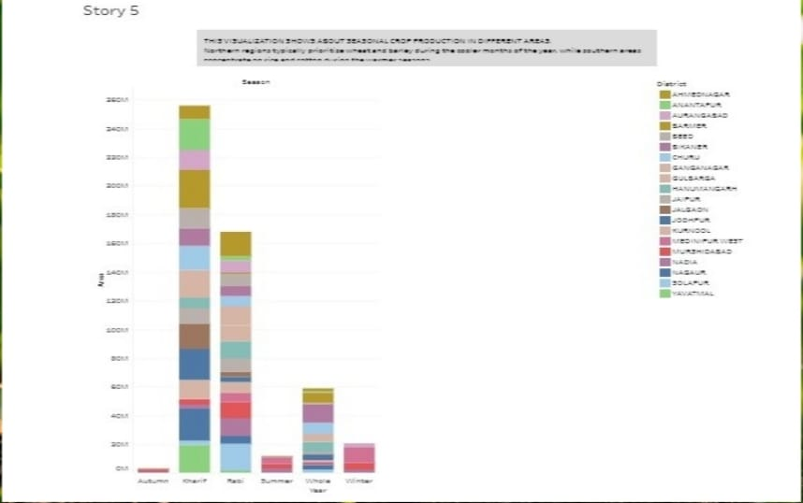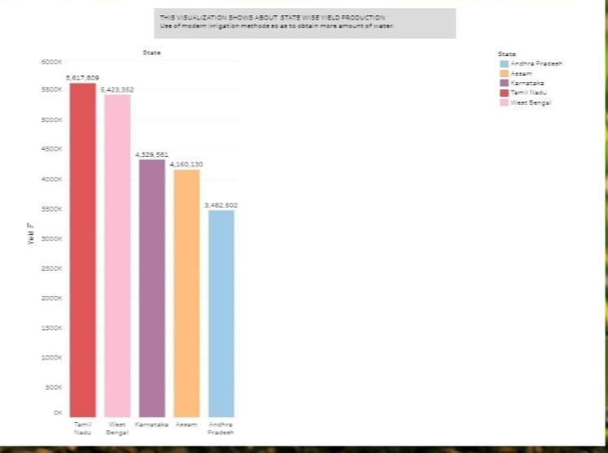

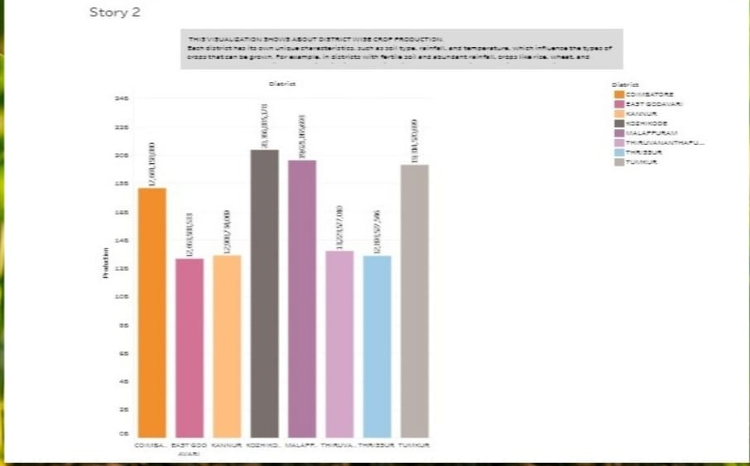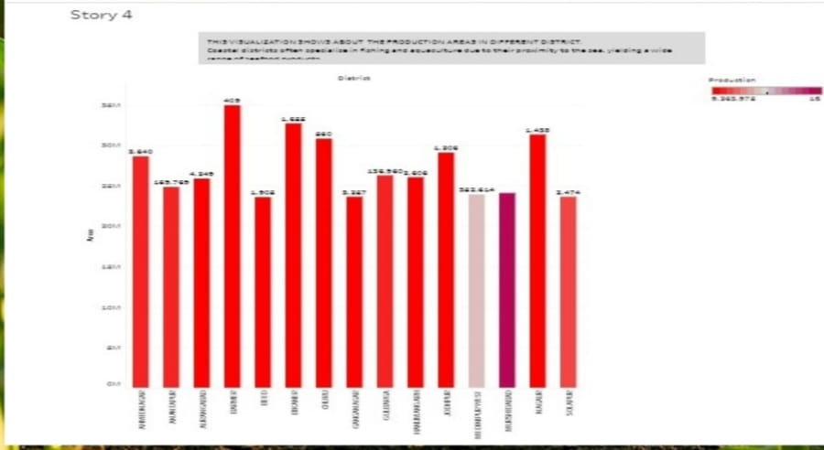

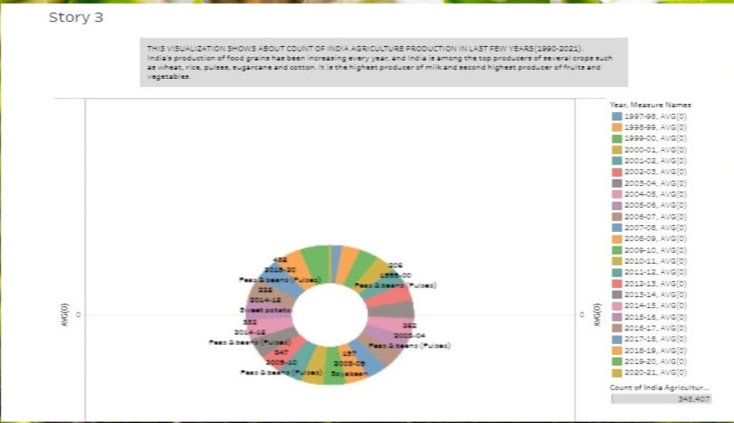

**ADVANTAGES AND DISADVANTAGES:**

**Advantages:**

There is overall increase in yield of crops mainly due to maintaining physical - chemical properties of soil. Soil fertility is restored by fixing atmospheric nitrogen, encouraging microbial activity (more organic matter) and protecting soil from erosion, salinity an acidity.

It helps in controlling insects, pests and soil borne disease . It also controls weeds. E.g. repeated wheat culture (growing) increases wild oats and phallaris infestation. Similarly growing berseem continuously encourage chicory(kasani) infestation , but an alternate cropping of berseem and wheat helps in controlling kasani as well as oats and phallaris.

Prevent or limit of peak requirements of irrigation water. Crops requiring high irrigation if followed by light irrigation , this will not affect or deteriorate the soil physical condition.

It facilitates even distribution of labour. Following crop make proper utilization of all resources and inputs. Family and farm labour, power, equipment and machines are well employed thought the year.

Farmers get a better price for his produce due to higher demand in local market. So there is regular flow of income over year.

**Disadvantage:**

Erosion of soil by heavy rain, floods, insufficient vegetation cover etc., reduces farm productitvity. In adequate irrigation facilities and poor management of water resources have led to a great decline in agricultural productivity.

Large -scale, conventional farming focuses on intensive single crop production, mechanization, and depends on fossil fuels, pesticides, antibodies, and synthetic fertilizers. While this system yields high production levels, it also contributes to climate change, pollute air and water, and depletes soil fertility.

There is no insurance against crop failure the farmer cannot sell anything from animal section in case there is crop failure , since it is only crop that the farmer is based on. There is no diversification of farm produce . Crops may be attacked by pests and diseases. Farmers have only one source of income.

**APPLICATION:**

There are two factors which are helpful for the farmers and the government in decision making namely:

It helps farmers in providing the historical crop yield record with a forecast reducing the risk management.

It helps the government in making crop insurance policies and policies for supply chain operation.

**CONCLUSION:**

The analysis of data reveals that the cropping pattern in India has undergone significant changes over time. There is a marked shift from the cultivation of food grains to commercial crops. Among food grains, the area under coarse cereals declined by 13.3 per cent between 1970-71 and 2007-08.

The agricultural marketing plays a vital role in easy way agro produce distribution to the customers. Like all the marketing activities, it also aims in profit making. It helps the farmers to reach their customers within very short lead time.

The agricultural sector is of vital importance for the region. It is undergoing a process of transition to a market economy, with substantial changes in the social, legal, structural, productive and supply set-ups, as is the case with all other sectors of the economy.

**FUTURESCOPE:**

Analyzing crop production in agriculture has a promising future, with a dvancements in technology and data-driven approaches. It helps optimize yields , reduce risks, and make informed decisions for sustainable farming practices.